Exception Handling in Java

1)What is Exception?

An **exception in Java** is an object representing an abnormal condition that occurs at runtime execution that interrupts (disrupts) the normal flow of the program.

Eg: If we enter a double value while the program expecting an integer value, we will get a runtime error called InputMismatchException.

2) Basically, there are two types of exceptions in java API. They are:

1. **Predefined Exceptions** (Built-in-Exceptions)
2. **Custom Exceptions**

3)Exception Hierarchy:

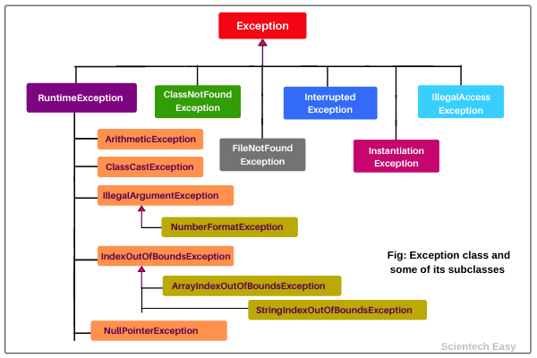

4)Unchecked Exception:

Unchecked exceptions in Java are those exceptions that are checked by JVM, not by java compiler. They occur during the runtime of a program.

All exceptions under the runtime exception class are called unchecked exceptions or runtime exceptions in Java.

Eg: ClassCastException, ArithmaticException.

5)Checked Exceptions:

The exceptions that are checked by Java compiler at compilation time is called checked exception in Java.

All the exceptions except RuntimeException, Error, and their subclasses are checked exceptions.

Eg: FileNotFoundException, ClassNotFoundException, InterruptedException.

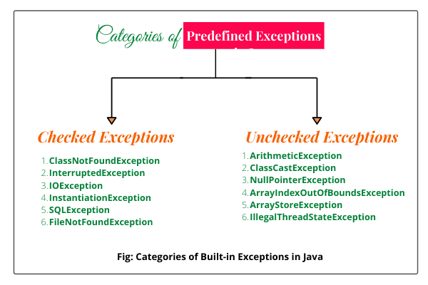

**Note:** Most people have confusion and say that checked exceptions occur at compile-time, that is wrong. All exceptions always occur at runtime only, but some exceptions are detected at compile-time and some other at runtime.

**7)** After a method throws an exception, JVM searches for a method in the call stack that contains a block of code that handles the exception. This process is called **catching an exception**.

A block of code that catches the exception thrown by JVM is called **exception handler**. This whole mechanism is called [*exception handling in Java*](https://www.scientecheasy.com/2020/08/exception-handling-in-java.html/).

**8)**while writing multiple catch blocks  All catch blocks must be arranged in such a way that exception must come from the first subclass and then superclass.

## 9) What is Unreachable Catch Block Error?

If we place superclass exception first and later on subclass exception, all the exceptions thrown for subclass exception will be caught by the first catch block.

In this case, the second catch block will not be used in the program and java compiler will generate **unreachable catch block error**.

## 10) Use of finally block in Java

1. Generally, finally block or clause is used for freeing up resources, cleaning up code, db closing connection, io stream, etc.

2. A java finally block is used to prevent resource leak. While closing a file or recovering resources, the code is put inside the finally block to ensure that the resource is always recovered.

3. Finally clause is used for terminating threads.

**Conditions where finally block does not execute**

There are the following conditions where finally block does not execute in Java. They are as follows:

1. When System.exit() method is invoked before executing finally block.

2. When an exception happens in the finally block.

3. When the return statement is declared in the finally block, the control is transferred to the calling routine, and statements after return statement inside finally block will not be executed.

**Throw in Java:**

1. We mainly use throw keyword to throw custom exception on the basis of some specified condition.

2. We use keyword throw inside the body of method or constructor to invoke an exception.

3. With the help of throw keyword, we cannot throw more than one exception at a time.

4. The keyword throw raises an exception by creating a subclass object of Exception explicitly.

**Throws in Java:**

**Throws keyword in Java** is used in the method declaration. It provides information to the caller method about exceptions being thrown and the caller method has to take the responsibility of handling the exception.

In Java exception handling, we use throws keyword to define a list of exceptions which may be thrown by that method.

**Difference between Throw and Throws in Java**

There are some key difference between throw and throws keywords in Java. They are as:

1. The keyword throw is used to throw an exception explicitly, while throws clause is used to declare an exception.

2. Throw is followed by an instance variable, while throws is followed by the name of exception class.

3. We use throw keyword inside method body to call an exception, while throws clause is used in method signature.

4. With throw keyword, we cannot throw more than one exception at a time, while we can declare multiple exceptions with throws.

**Methods of theowable class:**

 1. **getMessage():** The getMessage() method returns a detail message of exception that has occurred. The general syntax for getMessage

2. **toString():** The toString() method returns a short information about an exception in the form of string. The Throwable class overrides toString() method of Object class.

3. **printStackTrace():** This method prints the stack trace of an exception. It gives information about the name of exception, reason behind the exception, the line at which the exception occurs in the case of nested method calls. The general syntax for printStackTrace() method is as follows: